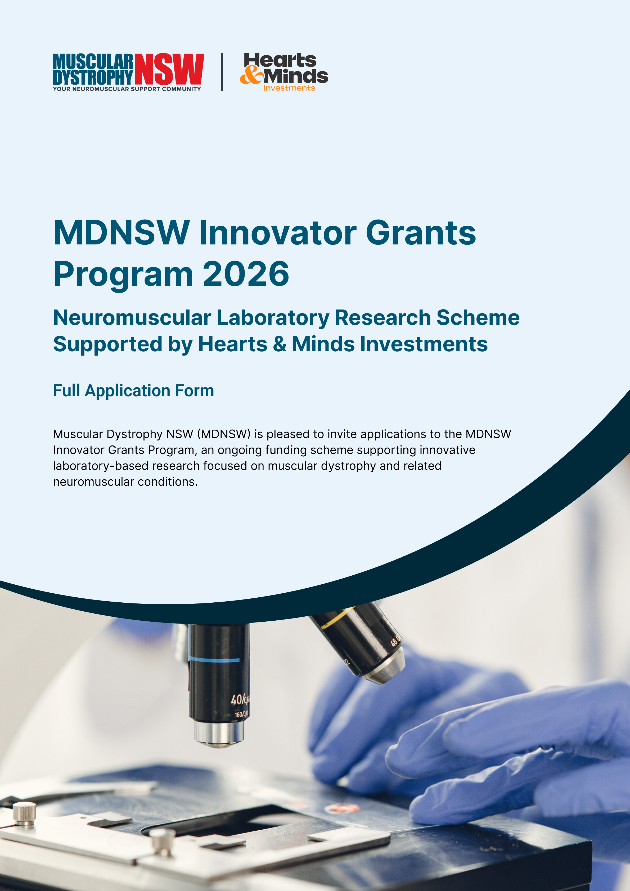

Instructions
Complete all sections and submit via email to info@mdnsw.org.au. Before submitting, please ensure:
☐ Application form is complete.
☐ Detailed budget template is completed and attached (download here).
☐ CVs for all investigators are attached.
☐ Declaration is completed and signed.

Applicant and Project Details
Chief Investigator (CI)
Name: |  | Title: |  | Position:

Administering Institution
Organisation: |  | Department/lab:
Email: |  |  |  | Phone:

Co-investigators
Names: |  | Roles: |  | Institutions:

Project Details
Project Title:

Duration (months): |  | Total funding requested ($):

Project Description
Provide the scientific background, current state of knowledge and rationale for the proposed research. Explain the gap, challenge or opportunity being addressed and why the project is important (max 500 words):

Define the project aim, including key research questions and objectives, and any hypothesis or hypotheses being tested if applicable (max 300 words):

Research Plan
Provide a detailed description of the proposed methodology (max 800 words):
Your response should address all of the following areas, as applicable:
a) Detailed experimental design
b) Controls
c) Endpoints
d) Replicates
e) Analysis Plan
f) Reproducibility considerations

What classification best describes this project?
☐ Wet lab
☐ Dry lab
☐ Both
Provide details of the models or systems (for wet lab research) and/or the data sources, datasets, pipelines and tools (for dry lab research) that will be used to conduct the proposed research (max 300 words):

3.1 Timeline and milestones
Provide the major milestones and associated outputs expected throughout the project. Milestones should be realistic, measurable and aligned with the proposed research plan. If additional space is required, please add rows to the table.

Month/Period | Milestone | Output/Deliverable

3.2 Risks and mitigation
Identify key risks that may impact project delivery. Outline strategies to mitigate these risks and any contingency plans that could be implemented. If additional space is required, please add rows to the table.
Likelihood Scale:
- Very Likely
- Likely
- Possible
- Unlikely
- Very Unlikely

Risk | Likelihood | Consequence/Impact | Mitigation/Contingency

Impact and Translation

Explain the relevance of this project to muscular dystrophy or other neuromuscular condition research (max 300 words):

Describe the outcomes expected within 12 months and define how success will be measured, including specific deliverables, outputs or achievements anticipated during the funding period (max 250 words):

Describe the project’s next steps and how research outcomes will be progressed beyond the funding period. This may include validation studies, preclinical development, follow-on funding (max 300 words):

Team and Environment
Provide a brief justification of the team's expertise, experience and track record relevant to the proposed project. Highlight previous achievements and capabilities (max 300 words):
Full CVs for all investigators should be submitted as attachments with the application.

Describe each investigator's role and expected contribution to the project, including the approximate percentage effort committed:
Investigator | Role | Effort (%)

Describe the research environment e.g. facilities, equipment, infrastructure, institutional support and specialist resources available (max 200 words):

Budget
Instructions
Complete the detailed MDNSW Innovator Grants Program 2026 Budgets template to outline all requested budget items and costs. Then, use the table below to provide an approximate allocation of the requested funding across the categories. Enter amounts in dollar values only ($).

Total funding requested ($)

Category | Approximate breakdown ($)
Personnel
Consumables
Core Facilities
Compute
Other

Has additional co-funding been secured or applied for?
☐ Yes ☐ No

Ethics and Regulatory Approvals
Please indicate whether each approval is required for your project. If approval is required, select the status. Funding may be conditional on the relevant approvals being obtained.

7.1 Human Ethics Approval Required?
☐ Yes ☐ No
Status (if required)
☐ Approved ☐ Submitted ☐ Planned
If planned, please provide the expected submission and/or approval date:
dd/mm/yyyy

7.2 Animal Ethics Approval Required?
☐ Yes ☐ No
Status (if required)
☐ Approved ☐ Submitted ☐ Planned
If planned, please provide the expected submission and/or approval date:
dd/mm/yyyy

7.3 Biosafety/Gene Technology Approval Required?
☐ Yes ☐ No
Status (if required)
☐ Approved ☐ Submitted ☐ Planned
If planned, please provide the expected submission and/or approval date:
dd/mm/yyyy

Consumer Relevance
In plain language, describe how this research could ultimately benefit people living with muscular dystrophy or other neuromuscular conditions. This response should be written for a non-scientific audience and avoid technical or academic language (max 150 words):


Declaration
Instructions
Please read the statements below carefully before signing.

By signing this declaration, I confirm that:
☐ the information provided in this application is true, accurate and complete to the best of my knowledge.
☐ the proposed project is laboratory-based research (dry lab and/or wet lab) and is directly relevant to muscular dystrophy and/or related neuromuscular conditions, with muscular dystrophy relevance central and explicit.
☐ the project will be administered by an Australian university, medical research institute, hospital/LHD, or other eligible research organisation.
☐ the requested budget is reasonable, directly related to the project, and does not duplicate funding already awarded or requested from another source for the same activities, unless expressly disclosed in this application.
☐ I have disclosed all current and pending support, actual, potential, or perceived conflicts of interest, and any commercial or financial interests relevant to this application.
☐ I understand that, if funded, the project must comply with all applicable ethics, biosafety, governance, animal welfare, privacy, and institutional requirements before relevant activities commence.
☐ I agree to comply with MDNSW grant conditions, including reporting, acknowledgement of funding, record keeping and request-for-variation requirements.
☐ I understand that MDNSW may seek clarification, verify information provided in this application, and apply conditions to any funding offer.
Applicant name: |  | Position/Title: |  |  | Institution:
Signature: |  |  |  | Date:  dd/mm/yyyy

Have enquiries about the program? Contact us.
 | info@mdnsw.org.au |  | 02 9888 5711 |  | www.mdnsw.org.au

